|  |  |  |  |  |  |  |  |  |  |  |
| --- | --- | --- | --- | --- | --- | --- | --- | --- | --- | --- |
|  |  |  |  |  |  |  | **ANNEX - I** | |  | |
|  |  |  |  |  |  | **Technical Specifications for Office Furniture** | | | | |
|  |  | | | | |  | |  |  |  |
|  | **Revolving Office chair** | | | | | | |  |  | |
| a. | Seat | & | Back | : | The seat and back shall be made of PU foam of density 45 ± 2 Kg/m3 | | | | | |
|  | Assembly | |  |  | upholstered with changeable fabric upholstery covers (as per requirement). | | | | | |
|  |  |  |  |  | Back Size: 480 mm. (W) X 550 mm (H) Approx. Seat Size: 480 mm (W) X | | | | | |
|  |  |  |  |  | 550 mm. (D) Approx. | | |  |  |  |
| b. | Base |  |  | : Five prong made of black color reinforced PU plastic with Nylon wheels and | | | | | | |
|  |  |  |  |  | pneumatic up & down with one point locking mechanism. | | | | | |
| c. | Handle armrest | | | : The armrest shall be | | | | gas-assisted injection molded from black | | |
|  |  |  |  |  | polypropylene. | | |  |  |  |
| d. | Revolving & tilt | | | : Chair should have a full 360o revolving mechanism with 17 deg. maximum | | | | | | |
|  |  |  |  |  | tilt only and tilt tension adjustment facility | | | | | |
| e. | Height of chair | | | : | Maximum and minimum height is approx. is 930mm and 830 mm | | | | | |
|  |  |  |  |  | respectively | | |  |  |  |
| f. | Powder coating | | | : Other visible metal parts and seat base support metal parts should be powder | | | | | | |
|  |  |  |  |  | coated with dry film thickness more than 50 microns, Salt Spray test to | | | | | |
|  |  |  |  |  | withstand more than 1000 hours, Pencil scratch hardness more than 2H, | | | | | |
|  |  |  |  |  | Adhesion as per DIN 53152 Standards. The powder coating shall be of good | | | | | |
|  |  |  |  |  | quality (7 process) to ensure good adhesion of life of the coating | | | | | |
| g. | Colour | of | seat | : The color of seat fabric are mentioned in the purchase order | | | | | | |
|  | upholster | |  |  |  |  |  |  |  |  |
| h. | Fabric |  |  | : Composition, Surface – 100% Polyamide, Substrate - 65 % (polyester) 35% | | | | | | |
|  |  |  |  |  | (cotton) Fabric shall have quality of user friendly for maintain cleanliness by | | | | | |
|  |  |  |  |  | simple vacuuming. | | |  |  |  |

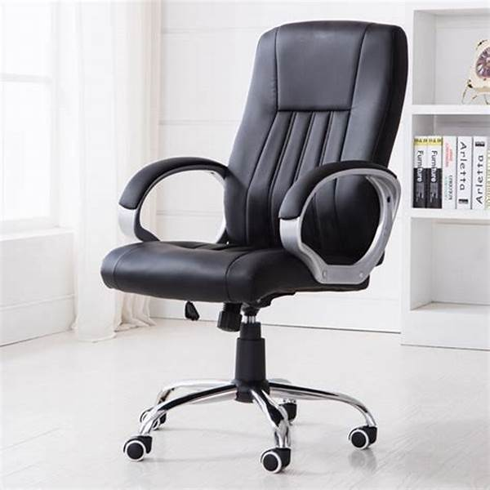

Pictorial view for chair

**Visitor Chair (3 Seater)**

|  |  |  |  |  |  |
| --- | --- | --- | --- | --- | --- |
| a. | Overall size | |  | : 1850 mm length, total height 770mm, depth 750mm for 3 seated chair | |
| b. | Seat Height | |  | : | Approx. 400 mm, |
| c. | Understructure | | | : It shall be made of SS J4/equivalent Grade tube Ø 44.4 mm. x 1.5 mm | |
|  |  |  |  |  | thick. TIG welded all-around the joints with grind and buffed finished |
| d. | Seat | & | back | : The mounting frames, 2 Nos. shall use to connect the side frames. The | |
|  | framing |  |  |  | mounting frame shall be made of MS ERW tube of Ø 50 & 31.5 mm |
|  |  |  |  |  | black painted. The seat /back shall be mounted on 40 x 20 x 2 mm MS |
|  |  |  |  |  | rectangular tube which shall be welded the beam of seat / back mounting |
|  |  |  |  |  | frame. |
| e. | Seat | & | back | : | The Seat / Back assembly shall be made from 12 mm thick plywood |
|  | foaming |  |  |  | insert |
|  |  |  |  |  | with polyurethane foam of density 45 ± 2 Kg/m3 and hardness - 20 ±2 on |
|  |  |  |  |  | Hampden machine at 25% compression with wood inserts for ensuring |
|  |  |  |  |  | long life and optimum comfort to the users. The complete seat and back |
|  |  |  |  |  | cushion shall be upholstered with satin repellant “Velveteen fabric”. |
| f. | Adhesive | |  | : Cellulose based high quality adhesive should be used to pest the foam | |
| g. | Colour | of | seat |  | The color of seat fabric shall be mentioned in the purchase order. |
|  | upholster | |  |  |  |

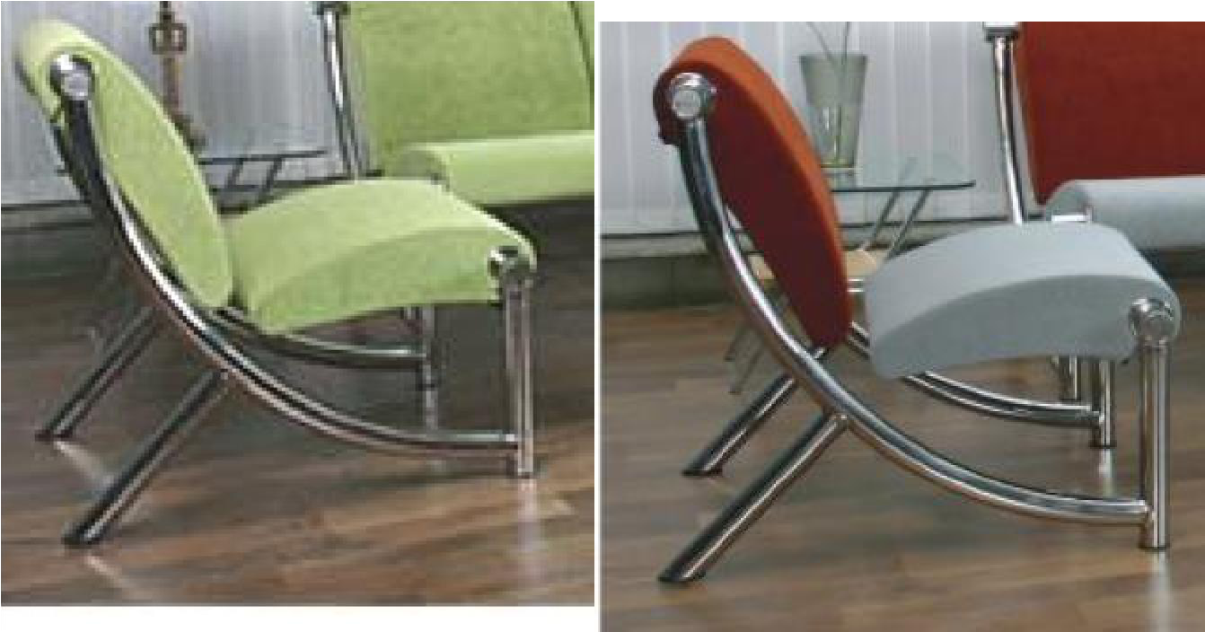

Pictorial view 03 Seated Lounge chair/Sofa

**Single seater visitor chair**

|  |  |  |  |  |  |  |
| --- | --- | --- | --- | --- | --- | --- |
| a. | Overall size | |  | : | 450mm length, total height 770mm, depth 750mm. | |
| b. | Seat Height | |  | : | Approx. 1200mm, |  |
| c. | Understructure | | | : It shall be made of SS J4/equivalent Grade tube Ø 44.4 mm. x 1.5 mm | | |
|  |  |  |  |  | thick. TIG welded all-around the joints with grind and buffed finished | |
| d. | Seat | & | back | : | The mounting frames, 2 Nos. shall use to connect the side frames. The | |
|  | framing |  |  |  | mounting frame shall be made of MS ERW tube of Ø 50 & 31.5 mm | |
|  |  |  |  |  | black painted. The seat /back shall be mounted on 40 x 20 x 2 mm MS | |
|  |  |  |  |  | rectangular tube which shall be welded the beam of seat / back mounting | |
|  |  |  |  |  | frame. |  |
| e. | Seat | & | back | : | The Seat / Back assembly shall be made from 12 mm thick plywood | |
|  | foaming |  |  |  | with polyurethane foam of density 45 ± 2 Kg/m3 and hardness - 20 ±2 on |  |
|  |  |  |  |  | Hampden machine at 25% compression with wood inserts for ensuring | |
|  |  |  |  |  | long life and optimum comfort to the users. The complete seat and back | |
|  |  |  |  |  | cushion shall be upholstered with satin repellant “Velveteen fabric”. | |
|  |  |  |  |  |  | |
| f. | Adhesive | |  | : | Cellulose based high quality adhesive should be used to pest the foam | |

1. Upholstered Fabric : Composition: Surface – 100% Polyamide, Substrate - 65 % (polyester) 35% (leather) Fabric must be user friendly to maintain cleanliness by simple vacuuming.
2. Upholstered color: The color of seat fabric shall be mentioned in the purchase order.

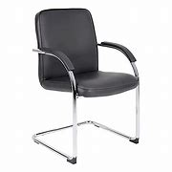

Pictorial view Single seater visitor chair

|  |  |  |
| --- | --- | --- |
|  |  | **Shared Computer Workstation** |

1. **Main Table**a. a. The size of workstation shall be 1800 mm (W) x 1800 mm (D) x 750 mm (H).
   1. The top should be made of 25 mm thick Pre-laminated board with 2 mm thick matching lipping.
   2. Stiffener (1.6mm thick) is to be provided under the top to give additional strength.
   3. Partition: the table shall be partitioned into 4 separate cubicles with 25mm thick pre laminated board with 2mm thick matching lipping.
2. **Under structure** a. The Pedestal shall be a combination of processed wood (PLB) and MildSteel (MS).
   1. Box drawers to be mounted under each cubicle
   2. Pedestal shell to be 0.80 mm thick MS sheet
   3. Drawer tray to be made from 0.6 mm thick M.S sheet
   4. Drawer separator to be made from 0.6 mm thick M.S. sheet
   5. PLB drawer fronts (18 mm thick PLB) to match the top color
   6. Drawers to be mounted on double extension steel telescopic ball slides to give full access to the drawer.
   7. Sleek handles for easy grip
   8. Glides screws for leveling
   9. Independent locking arrangement (cam lock) for each pedestal
   10. Powder coating on all items with dry film thickness more than 50 microns, Salt Spray test to withstand more than 1000 hours, Pencil scratch hardness more than 2H, Adhesion as per DIN 53152 Standards. The powder coating shall be of good quality (7 process) to ensure good adhesion of life of the coating.
   11. Panel recessed inside for more legroom.
   12. Panel to be styled with cut-outs ( windows) for better physical appearance

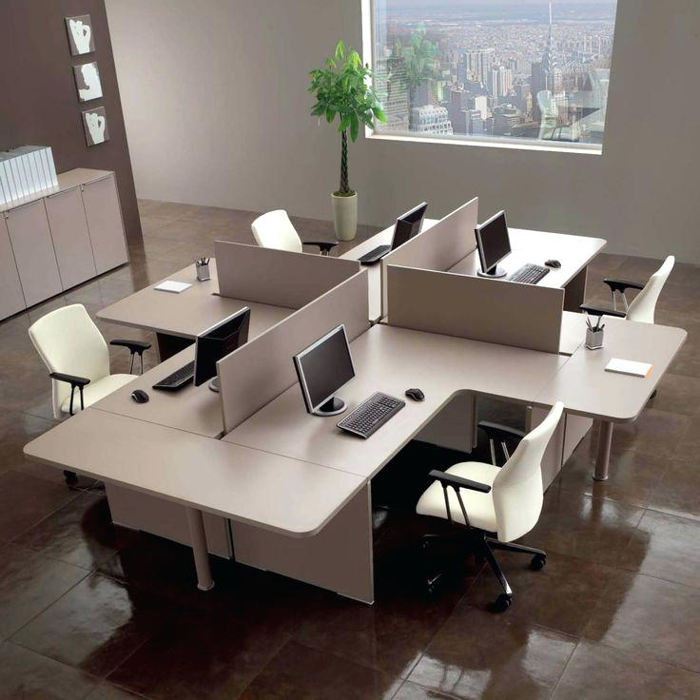

Pictorial view of Shared workstation. (Accessories shown is not part of supply)

|  |  |  |  |  |  |
| --- | --- | --- | --- | --- | --- |
|  |  | |  | **Coffee table** |  |
| a. | Over | all | : | 1000mm length, total height 450 mm, depth 650mm. | |
|  | Dimension |  |  |  |  |
| b. | Understructure |  | : | Base frame made by 75x75 mm Sq. thick. CP teakwood duly polished | |
|  |  |  |  | with mahogany melamine finished. | |
| c. | No. of shelves |  | : Two nos. top made of glass and middle wood baton. | | |
| d. | TopGlass | & | : | 10 mm thick toughen glass with etching work. Glass support shall be | |
|  | Support |  |  | vacuum button fitted on all corner. | |

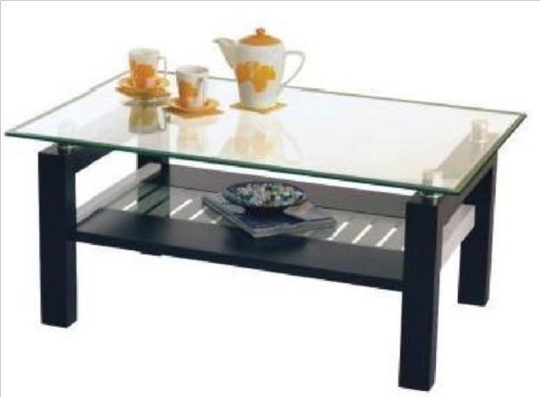

|  |  |  |  |  |
| --- | --- | --- | --- | --- |
|  |  |  | **Stainless Steel Top Serving Table** |  |
| a. | Overall size | : | 1200mm (Approx.) Length, 450mm depth and height 750mm | |
| b. | Understructure | : | 1000mm x 400mm x 720mm, leg pipe size 30mm x 30 mm x 1.2mm S.S. | |
|  | Main |  | 304 materials. |  |
| c. | Cross member | : 25mm x 25mm x 1.2mm thick of S.S. 304 tube | |  |
| d. | Welding | : | TIG welding all-around the weld joints using inert gas (Argon.) | |
| e. | Joint Finish | : | All joints should be grinded and properly finish smoothing the structure. | |
| f. | Table top | : | 18mm thick. Plywood of ISI303 grade, top molded and pasted all around | |
|  |  |  | except bottom with 1.0 mm thick SS 304 sheet. The sharp edge should be | |
|  |  |  | removed. The bottom of table top should be white painted. | |
| g. | Table top fittings | : Fitted with S.S. screw with structure. | |  |

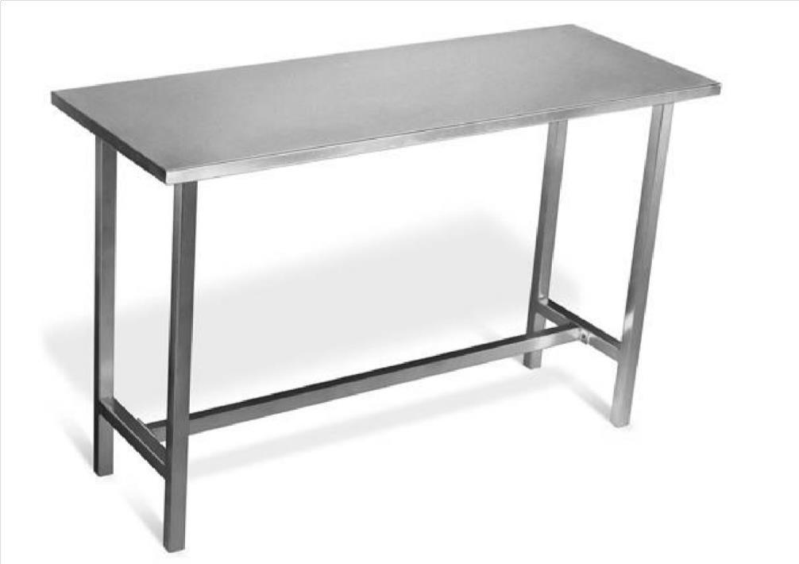

Pictorial view of Serving Table.

**Premium Executive Table**

1. **Main Table**a. The size of main table shall be 1800 mm (W) x 900 mm (D) x 740 mm (H).
   1. The top should be made of 25 mm thick Pre-laminated board with 2 mm thick matching lipping.
   2. Stiffener (1.6mm thick) is to be provided under the top to give additional strength.
2. **Understructure** a. The Pedestal shall be a combination of processed wood (PLB) and MildSteel (MS).
   1. Box drawers and 1 filing drawer combination for both pedestals
   2. Pedestal shell to be 0.80 mm thick MS sheet
   3. Drawer tray to be made from 0.6 mm thick M.S sheet
   4. Drawer separator to be made from 0.6 mm thick M.S. sheet
   5. PLB drawer fronts (18 mm thick PLB) to match the top color
   6. Drawers to be mounted on double extension steel telescopic ball slides to give full access to the drawer.
   7. Sleek handles for easy grip
   8. Glides screws for leveling
   9. Independent locking arrangement (cam lock) for each pedestal
   10. Powder coating on all items with dry film thickness more than 50 microns, Salt Spray test to withstand more than 1000 hours, Pencil scratch hardness more than 2H, Adhesion as per DIN 53152 Standards. The powder coating shall be of good quality (7 process) to ensure good adhesion of life of the coating.
3. Panel recessed inside for more leg room.
4. Panel to be styled with cutouts ( windows) for better physical appearance

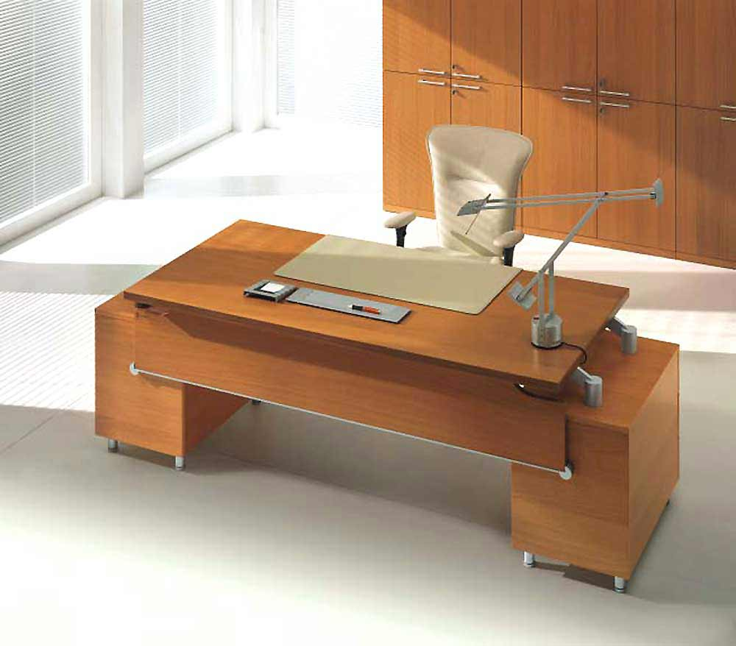

Pictorial view of premium executive table. (Accessories shown is not part of supply)

**Office Filing Cabinets**

Main Cabinet: Metal vertical file cabinets are constructed of premium quality cold rolled steel with 16-gauge base, 18-gauge top/bottom and 20-gauge sides/ back. The drawer bodies are 22 gauge and the fronts are 20 gauge. The case consists of welded joints and upright braces for rigidity

Drawers: Steel ball bearing drawer slides.

Includes a 16 gauge positive follower plate to secure files and provide safety.

Brushed aluminum drawer pulls. Label frames are standard on each drawer front.

Hanging file racks are included in each drawer.

Configurations: 2 Drawer Letter and Legal sizes, 3 Drawer Letter and Legal sizes, 4 Drawer Letter and Legal sizes.

Keys: Two keys should furnished with each unit. Master keys and key blanks are available.

Units may be keyed alike at no additional cost.

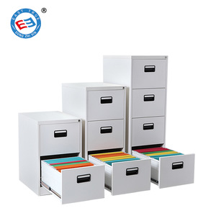

Pictorial view of Office filling cabinet

**7/8 |** P a g e

|  |  |  |  |  |
| --- | --- | --- | --- | --- |
|  |  | | **Steel Almirah** |  |
| a. | Overall size | : | 1270 mm (H) x 765 mm (W) x 440 mm (D) |  |
| b. | Materials | : | The CRCA steel sheet used for the body should be 0.9 mm thick, | |
| c. | Construction | : | It should interlocking design and full length over lapping doors and sides. | |
|  |  |  | It should have three way bolting mechanism. The two doors have hinge | |
|  |  |  | mounted on frame |  |
| d. | Doors | : | The doors have one handle and lever locking mechanism with | |
|  |  |  | 6- Six lever Mazak Zinc Plated Lock. |  |
| e. | Powder coating | : | All steel components should undergo eight tank anti rust treatment and | |
|  |  |  | oven |  |
|  |  |  | Baked epoxy polyester powder coating with 50-60 micron dry film | |
|  |  |  | thickness. Salt Spray test to withstand more than 1000 hours as per IS 101, | |
|  |  |  | Pencil scratch hardness more than 2H, Adhesion as per DIN 53152 | |
|  |  |  | Standards. |  |
| f. | Shelves inside | : | It should have 4 adjustable shelves made of 0.8 mm thick CRCA steel | |
|  | Almirah |  | sheet. |  |

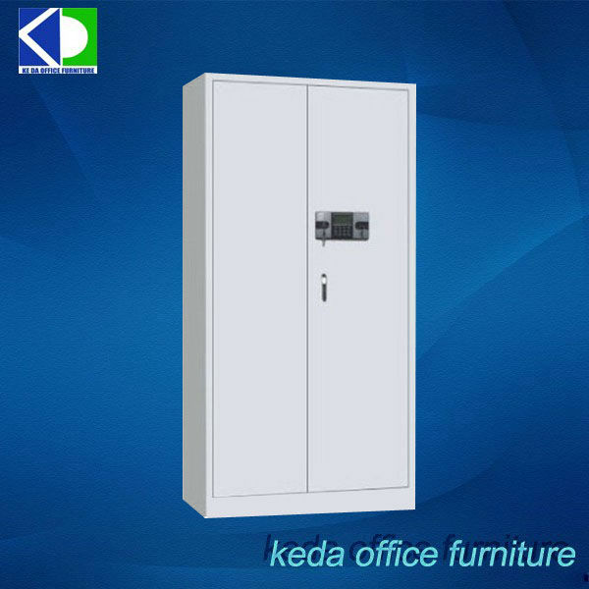

**Student/Pupils Furniture**

**Desk:** the size of the desk shall be1000X400X720mm 3/4" MDF Board sealed round with 3mm matching edge tape/lipping.

**Seat:** 1000X250X440mm 3/4" MDF Board sealed round with 3mm matching edge tape/lipping.

**Box/locker:** 900X200X375mm 3/4" MDF Board sealed round with 3mm matching edge tape/lipping.

**Back:** 1000X160X750mm 3/4" MDF Board sealed round with 3mm matching edge tape/lipping.

**Colour:** will be specified as the need arises

**Metal works:** 1.5"X1.5"X 2mm thick square black pipe

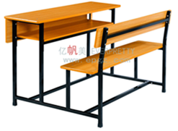

**Queen size Complete Bed set(drawers and headboard)**

**The Bed:** the size of the bed shall be1930mmX2030mm 3/4" MDF Board sealed round with 3mm matching edge tape/lipping.

**Material:** 3/4" MDF Board sealed round with 3mm matching edge tape/lipping.

**size:** 76 inches (193 cm) by 80 inches (203 cm)

**Design:** Beds should come in a modern design with a headboard and, and a firm support system

**Colour:** will be specified as the need arises

**Frame:** The frame is required to have a center leg support besides the normal rectangular structure.

**Accompanying accessories:** bedside table, mattress, Dresser

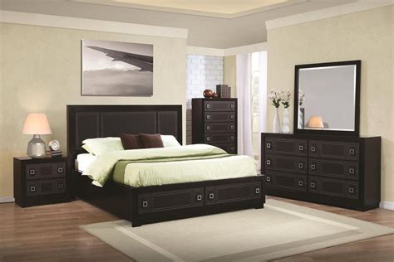

**Contemporary 6 seater Living room Sofa set and tables**

**The Set:** the sofa is a set of three sofas with one no 3 in 1 settee, 2 in 2 and a single settee, making a total of 3 settees in one sofa set.

**Fabric:** Durable Natural fibres made from plant-based cotton and linen, along with silk and wool, densely woven and moth proofed.

**Design:** Sofa should come in a modern design with a headboard and, and a firm support system

**Colour:** will be specified as the need arises

**Frame:** The frame is required to have a centre leg support besides the normal rectangular structure.

**Accompanying accessories:** coffee table, centre table

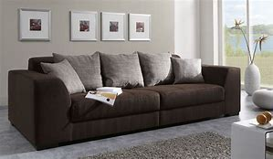

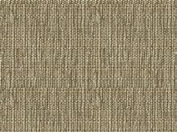

**Contemporary 6 seater dining set**

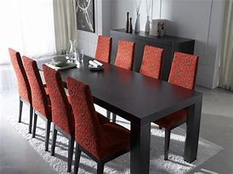

**Notes:-**

1. The furniture should be from an ISO 9001, ISO 14001, and OHSAS 18001 certified manufacturer. All the certificate should be attached with the quote.
2. OEM (Original equipment manufacturer) or their authorized dealers are only eligible to bid. Proof of dealer authorization from OEM currently in force shall be enclosed to bid.
3. Supplier should enclose a detailed technical literature/ product catalogue in support of the offered items and supplier shall mention the make and model no. of the items in their quotations.
4. CRCA steel sheet used in furniture shall be as per IS-513 1994 or latest standard.
5. Overall size variation should be within ± 2%
6. Supplier shall provide the color options available with manufacturer for paint (for Amirah and tables etc.), laminate /mica, Sofa and chairs (seat cloth) in their quotation clearly. Our

choice for the same will be mentioned in Purchase Order among the available options with the manufacturer.

1. Pictorial view of each office furniture enclosed is only indicative. The actual product of company may have different look, but must meet all the technical specification.
2. One year manufacturer warrantee should be provided from the date of final acceptance.
3. Pre dispatch inspection will be carried out as per our specification.
4. Packing and forwarding: Furniture should be packed with good quality proper packing material, so that furniture shall reach to RRCAT stores without any dent, scratch and damage. Material with any dent, scratch and damage condition will not be accepted at all.
5. Delivery of material shall be within 45 days from the date of purchase order.

------ End of specification -----